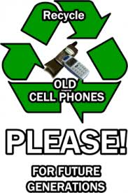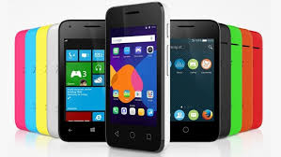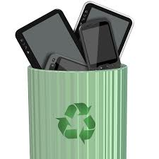

* Who: You!
* What: Cell Phone Recycling Drive
* Where: Little Shop of Stories, Fleet Feet
* When: April 18-22 (Business Hours)
* Why: To do our part in protecting the environment!

photo

🙞 🙜

#### Cell phones should always be recycled. Less than ten percent of cell phones are recycled each year. You can recycle at a lot of different places. I want you to recycle as much as you can.

Should Cell Phones be Recycled?

#### All other electronics can be recycled at Decatur Public Works on Saturday, April 2, from 9-1.

photo

# Call to Action

## Recycling Drive

### Ms.Hardnett Clairemont Elementary School March 31, 2016

William Taylor

## Monetary Costs

It cost a lot of money to extract metals. Which means when you throw away obsolete cell phones it basically means your throwing away money, but if you recycle cell phones you could save a lot of money. It may not cost a lot to make 1 cell phone but it cost a lot to make a cell phone for every person in the world. It cost A LOT! The value of metals is a lot of money like gold’s value is 199 million dollars and silvers value is 31 million.

When you don’t throw away your cell phones that aren’t being used there are environmental costs. Like destruction of habitats, land water and air pollution, and extracting too much metals. That is super bad pollution can kill animals and their environments. If the miners extract too many metals for your phones then it pollutes the earth too.

If you thought throwing away cell phones was good then you thought wrong. Cell phones contain a lot of metals including copper, silver, gold, and aluminum. In 2007, there were 180 million cell phone subscribers. Less than 10 percent of the millions of cell phones that are retired and discarded annually are recycled. INFORM inc. anticipated that by 2005 out of a total of 500 million obsolete cell phones, less than 10 percent of those cell phones are recycled.

## Introduction

## Environmental Costs